**PRACTICAL No.5**

**AIM:** **Write a Program to read two integer numbers and find the product of the numbers.**

**STEPS:**

#Write a Program to read two integer numbers and find the product of the numbers.

num1=int(input("Enter first number: "))

num2=int(input("Enter second number: "))

print(num1*num2)

_________________________________________________________________________________________________________________________________________________________________________________________________________________________________________________________________________________________________________________________________________________________________________________________________________________________________________________________________________________________________________________________________________________________________________________________________________________________________________________________________________________________________________________________________________________________________________________________________________________________________________________________________________________________________________________________________________________________________________________________

**SCREENSHOT:**

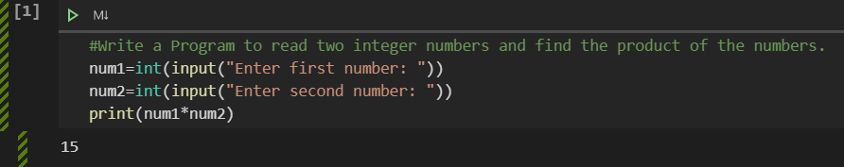

**Date:**